NAME :- Lokare Mahir Abdul Majeed
ROLL NO :- 23AI34

BATCH :- 02

EXPERIMENT NO :- 01

AIM :- To install and configure the Anaconda Distribution on a local machine and verify the setup by launching the Navigator and running a Python command.

THEORY :-
Anaconda is an open-source distribution of the Python and R programming languages, specifically designed for scientific computing, data science, and machine learning workflows. Its central purpose is to streamline package management and deployment, eﬀectively mitigating "dependency hell" the complex conflicts that arise between diﬀerent software libraries. The distribution is built around Conda, a cross-platform package and environment manager that allows users to install library dependencies and switch between isolated environments seamlessly.
Unlike a standard Python installation, Anaconda is a "batteries-included" platform, pre-installing over 1,500 essential data science packages like NumPy, Pandas, and Scikit-learn, along with integrated development environments (IDEs) such as Jupyter Notebook and Spyder. By decoupling project environments from the global system, Anaconda ensures reproducibility and stability, allowing researchers to experiment with diﬀerent toolchains on a single machine without the risk of system-wide corruption. This makes it the foundational tool for establishing a robust, ready-to-use laboratory environment for computational experiments.
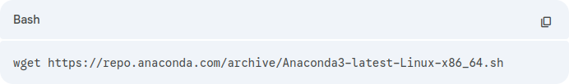
Step 1: Download the Installer Open your terminal and download the latest Anaconda installer script using the wget command.

Step 2: Verify the Download (Optional) Ensure the data integrity of the installer using the SHA-256 checksum.
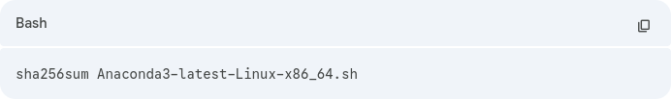

Step 3: Run the Installation Script Execute the downloaded bash script to start the installation process.
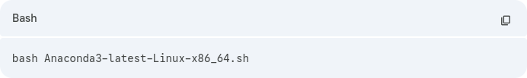

Step 4: Follow the License Prompts
- Press Enter to review the license agreement.

- Scroll to the bottom and type yes to accept the license terms.
- Press Enter to confirm the default installation location (usually
/home/username/anaconda3).
Step 5: Initialize Anaconda When prompted "Do you wish the installer to initialize Anaconda3 by running conda init?", type yes. Once the installation finishes, refresh your shell environment to make the changes active:
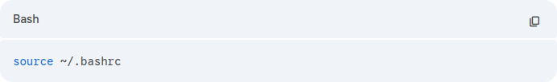

Step 6: Verify Installation Check that Anaconda is installed correctly by querying the version.
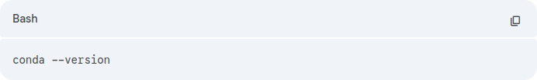

Step 7: Launch the Interface To verify that the graphical interface works, launch the Anaconda Navigator:
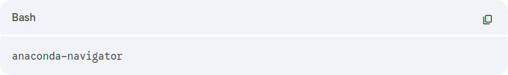

OUTPUT :-
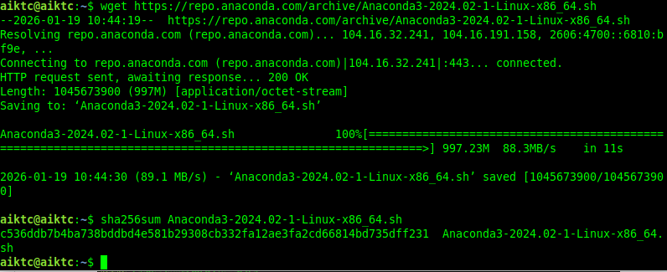
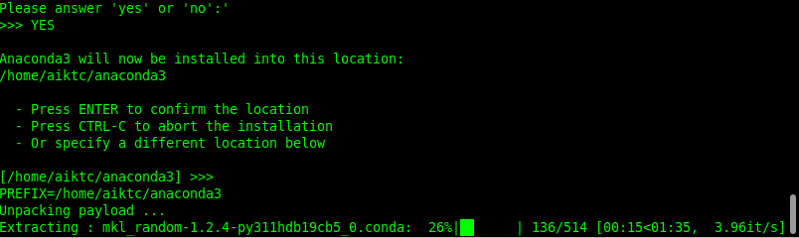

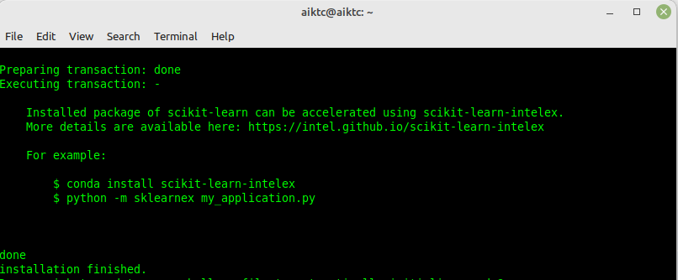
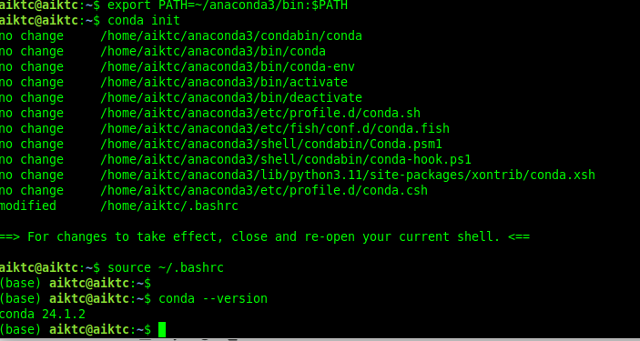

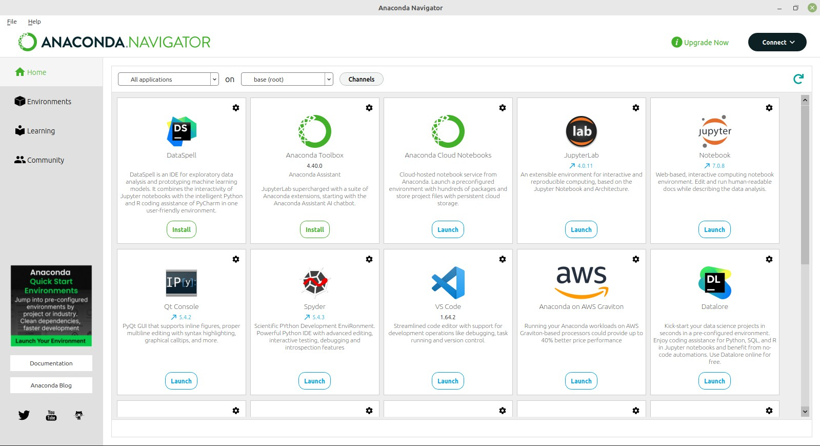

CONCLUSION :-
The Anaconda distribution was successfully downloaded, installed, and configured on the Linux environment. The system path variables were correctly set, ensuring the conda command and related development tools are accessible globally. Verification was confirmed through a terminal version check and the initialization of the Anaconda Navigator. The system is now fully prepared for data science workflows and isolated Python development.

